1. Create a program for university with 2-classes (Employee, Department). Several employees can work in one department. Every time department wants to hire a new employee, a method should be called to do the following:

* Department budget should increase with employee’s salary
* Employee should belong to that department

Department.java

**public** **class** Department {

**int** Totalbudget=500000;

**int** salary;

**int** budgetForSalary;

String name;

String emp[]={"Ayesha"};

**public** Department (){

System.*out*.println("Printing the state before executing method\n salary="+

salary+"\n Budget For Salaries="+budgetForSalary+"\n Name="+name+

"\nTotal Budget="+Totalbudget);

}

**public** **int** hireEmployee(String name, **int** salary) {

budgetForSalary=budgetForSalary+salary;

Totalbudget=Totalbudget+salary;

**if**(Totalbudget>budgetForSalary){

**try**{

emp[emp.length]= name;

}

**catch**(Exception e){}

}

System.*out*.println("Printing the state after executing method for "+ name+

" \nsalary="+

salary+"\n Budget For Salaries="+budgetForSalary+"\n Name="+name+

"\nTotal Budget="+Totalbudget);

**return** Totalbudget;

}

}

Employee.java

**public** **class** Employee {

**public** **static** **void** main(String[] args) {

Department emp= **new** Department();

**if** (emp.hireEmployee("Rabia", 15000)==515000)

System.*out*.println("Expected output was 515000, recieved "+ emp.Totalbudget+ " Test Passed!!");

**else**

System.*out*.println("Test failed!");

**if** (emp.hireEmployee("Iftikhar", 10000)==525000)

System.*out*.println("Expected output was 525000, recieved "+ emp.Totalbudget+ " Test Passed!!");

**else**

System.*out*.println("Test failed!");

**if** (emp.hireEmployee("Zainab", 20000)==545000)

System.*out*.println("Expected output was 545000, recieved "+ emp.Totalbudget+ " Test Passed!!");

**else**

System.*out*.println("Test failed!");

}

}

**Output**

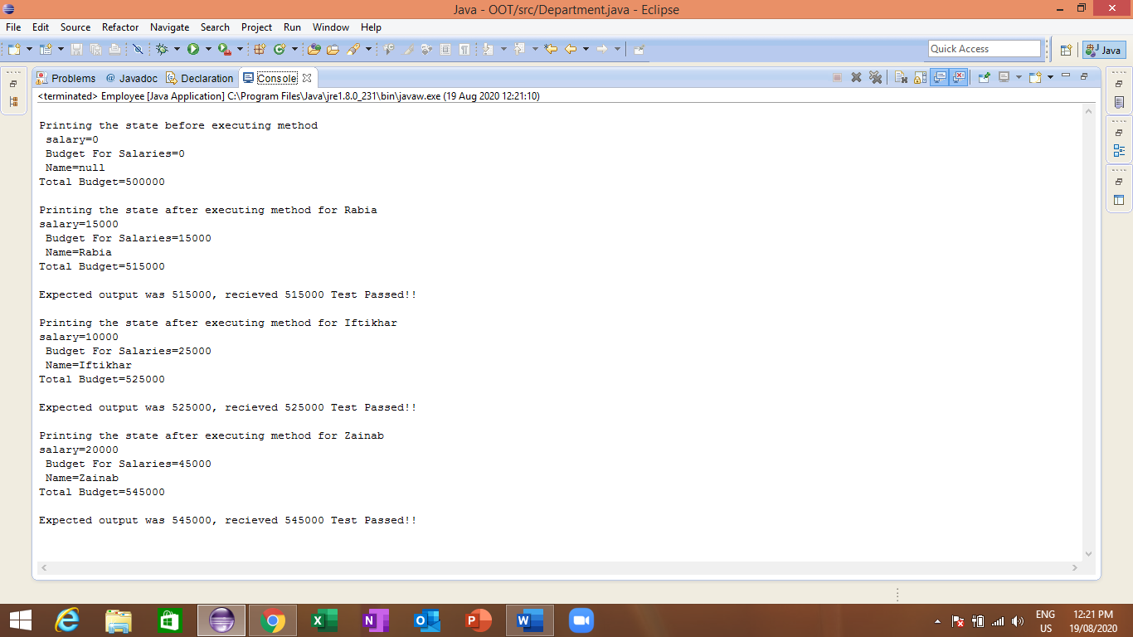

**Since the method execution is taking us to the expected states for all the three time (i.e. when called with name Rabia, Iftikhar, and Zainab), we conclude this code without any failure.**